danger of the global warming and climate change. We have conducted two programmes on global warming and climate change for the college students at the Womens Christian College, Nagercoil and Scot Christian College, Nagercoil.
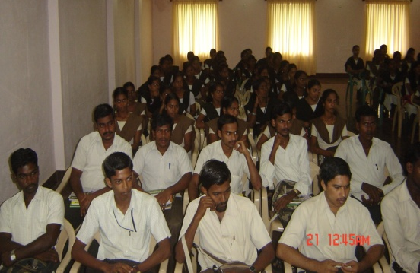

The first programme was held on 15th July 2010 at Scott Christian College, Nagercoil and the second programme on 16th July 2010 at Women Christian College, Nagercoil. Hundreds of students were benefitted.

- Flood Relief Programme:

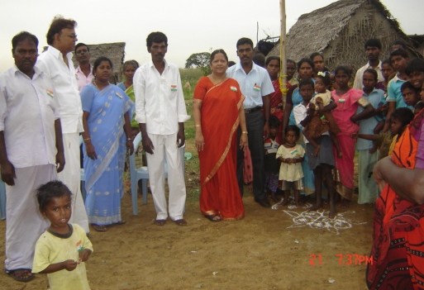
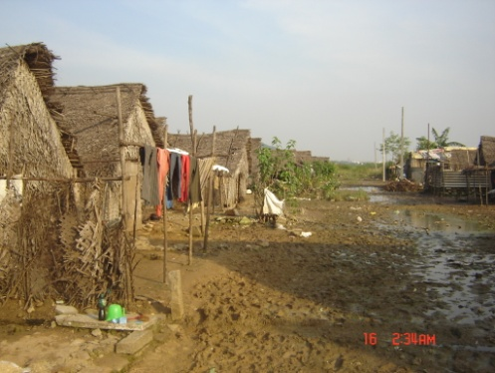
The Annai Anjugam Nagar Manapakkam is located near Tambaram. About 110 families(400 people) were living in huts at the bank of the river near Porur. Their settlement was gutted by fire. The Tamilnadu Government allotted a place in the lake area near Tambaram en-route Kishkinda. All the families are living in huts. The walls of the hutments are made up of Palm leaves. The huts have no cement floors. People live with children on the mud floor. The settlement has no facility for the supply of electricity. Our interviews with them revealed that these people have migrated from Vathalagundu village in Madurai area. They work as labourers in local companies. Their settle is absolutely vulnerable, since their settlement is right in the middle of a lake. The rain water enter their huts even with a moderate shower. The local Panchayat provided them temporary shelter for a week, in a government school near Tambaram during the last monsoon season.
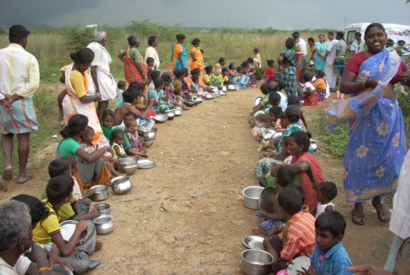
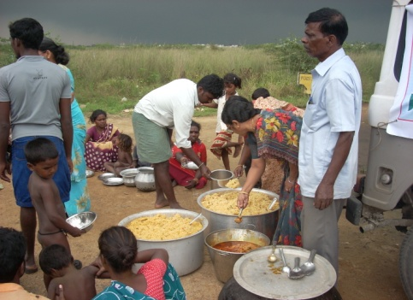

Our Council has already done small programmes in that area such as children programme, women programme, etc. Last year we celebrated Independence day with them. Hence they approached us for help during the time of rain and floods.

With the help of CASA, we were able to do feeding programme for three days.

We supplied Bread, one time for children of Anjuigam Nagar and Samathuvapura, and Periyar Nagar as the people from both the colonies were residing at the temporary shelter in the Govt. school on 08-12-2010.

Lunch (Vegetable biriyani with brinjal patchady) on 14-12-2010.

Lunch (Bisibellabath – rice, dhall with vegetables) on 15-12-2010

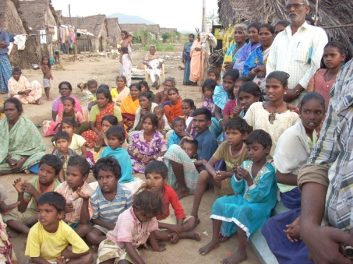
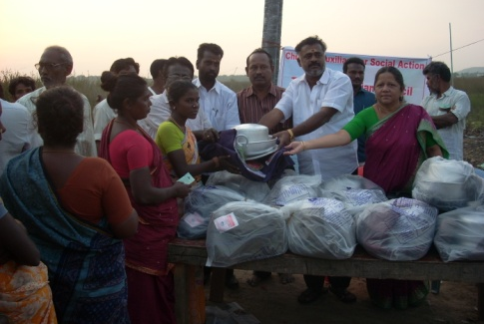
On 26th December 2010, we distributed Relief kits to all the 110 families each containing a dhoti, a sari, a blanket and cooking vessels. The Panchayat leader came and distributed the materials.

- Medical Camp:

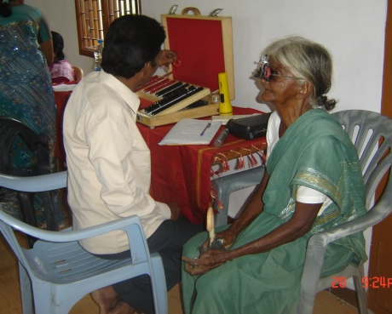
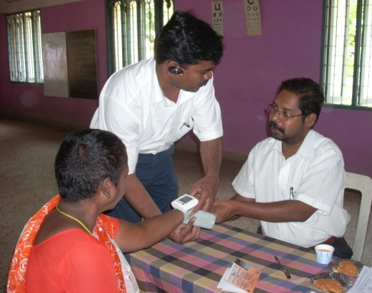
Free Eye and diabetic testing camp was conducted for the local community at St. Thomas Mount area at CSI Tamil Wesley Church, ST.Thomas Mount, Chennai on 7th August 2010. The medical doctors from Rajan Eye Hospital were invited to do the testing. About 130 persons were benefited. About 8 elderly persons underwent free cataract operation and provided free spectacles. The Pastor and the local Church members were very helpful in organizing the camp.

Free Eye and diabetic testing camp was conducted at CSI Church, Vellavedu on 22nd Aug 2010. Doctors from Radhatri Nethralaya, T.Nagar were invited to do the testing. 82 persons were benefited. 2 elderly persons underwent cataract operation and provide spectacles free of cost.
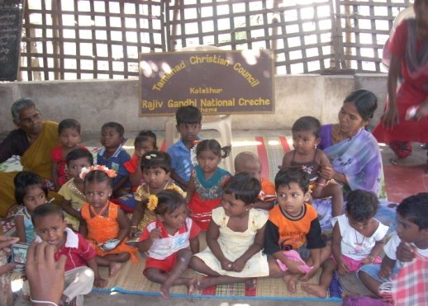
- Crèche Centers:

With the sponsorship of the Central Social Welfare Board, New Delhi, and through the

