Tamilnadu Social Welfare Board we are implementing Rajive Gandhi National Creche Scheme at the following places. Approximately 20 to 30 children between age group from 2 to 5 years receive care and attention.
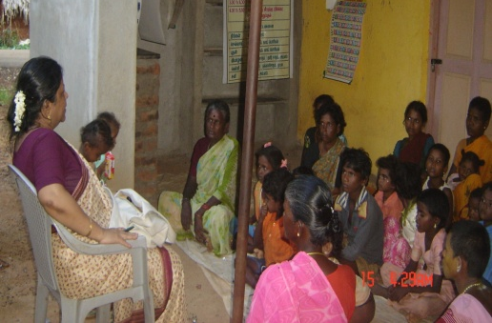
1. Kazhanipakkam, Ambur
2. Nemalur, Gummidipoondi
3. Pondavakkam, ,,
4. Memorial Hall,
5. Kilpauk
6. Delta, Kadalur
7. Parameswarimangalam
8. St. Paul’s Church, Vilupuram,
9. Kollathur, Chennai.
10. Thandalachery, Gumidipoondi.

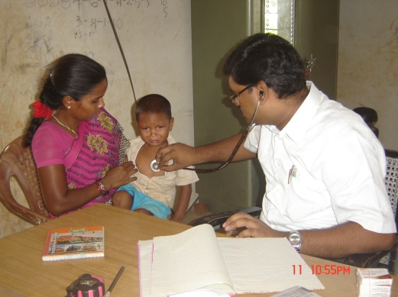
The Director regularly visit all the Creche Centres and also meets the parents of the children. Medical check-ups were done to all the children in all the crèches. In most of the places even the village people were given medical treatment. Emergency medicines were kept in the centres.

- Bethesda Home:

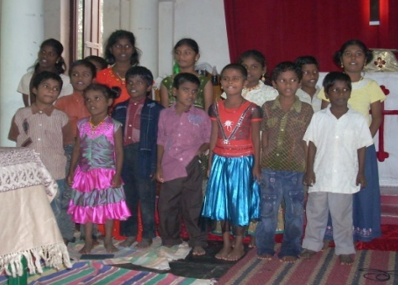
Bethesda Children home is our orphanage at Chingleput. In our Bethesda Home 16 children are staying and they are studying in the nearby Government School. The maintenance of the home and care for the Children and other expenses of the home and part of the functioning of Chingleput Rural Service and Development Center are met through the income we receive as rent from the shops.

Children Home at VOC Nagar, Chingleput was established specifically to provide care for the HIV positive children and the mentally challenged children. The Karunai Jeevan Trust helps us to run this project and also take care of the maintenance.

10.Adult Literacy Programme:

We were conducting Adult literacy Programme for the past 10 years in 20 different centres. The project was closed. Yet upon the request of the local people we are continuing the programme at four centres viz.

Kancheepuram -Vedal (Guduppu Community );
K.K. Nagar at Thirukazhukundram,
Kulipanthandalam
Oragadam

11.HIV/AIDS Awareness Training Programme:

During this year HIV/AIDS Awareness Programmes have been conducted at 10 places.

HIV/AIDS Awareness Training Programmes :-

S.No. | Places | Participants Details | No. of  Participants
1. | Chennai | Youth group | 30
2. | Chennai | Youth group | 28
3. | Ambur | Women group | 35
4. | Chingleput | ,, ,, | 42
5. | Madurai | Youth group | 58
6. | Irukkam Island | Youth | 25
8 | Tirunelveli | Youth | 35
9. | Gumidipoondi | Women group | 52
10. | Kancheepuram | Women | 32

World AIDS Day : We have organized a Rally and an awareness programme along with the CSI St.Thomas Matriculation School Children, St. Thomas Mount. Mrs. Rokkiah (a) Salma, Chairman, Tamilnadu Social Welfare Board was invited as the Chief guest.
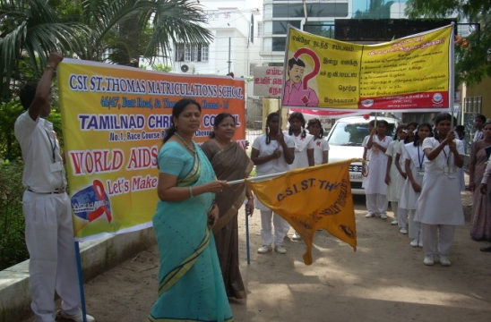
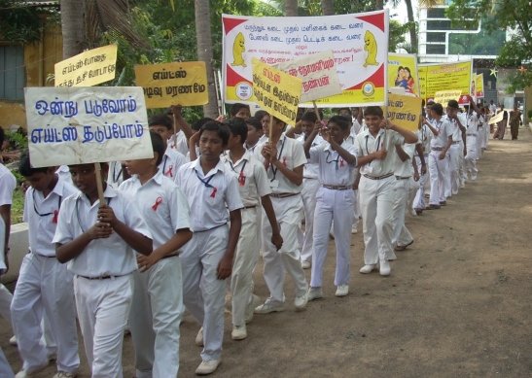

12. Ambur Resource Center - Dedication:

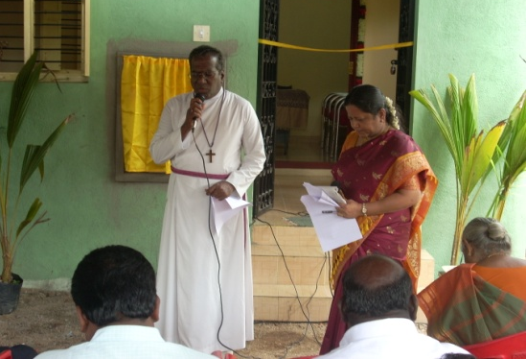
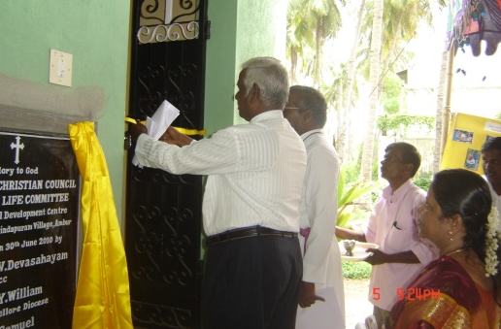
The newly constructed Ambur Resource Center was dedicated by our President Bishop, the Rt. Rev. Dr. V. Devasa -hayam, on 30th June 2010. The Rev. Dr. J. Samuel, President of the I.E.L.C. opened the building by cutting the ribbon. Mr. Sunder Kumar, our treasurer and some of our Members, Staff and the beneficiaries attended the programme. Dr. Ms. V. Esther Kathiroli, Director welcomed and honored all the dignitaries. Dr. Jayakaran Isaac, our member, Dr. Joel Nesakumar, Medical Director, Bedestha Hospital, Rev. John Baskaran, Vice President, CSI Vellore Diocese offered greetings. Our President delivered Lord’s Message.

13. Community Development Programme at Irrukam:

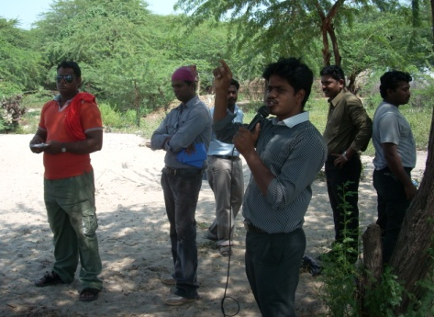
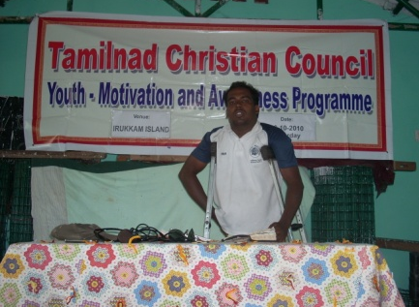
Last year we have planted cashew nuts seedlings and casurina seedlings. Some of the cashew nuts trees dried due to over heat but some have survived and have grown big. But all the casurina seedlings have survived and have grown.

Women programme and children programme are continuing. Youth awareness and motivation programme was conducted by the youth at Chennai to the youth at Irrukam.
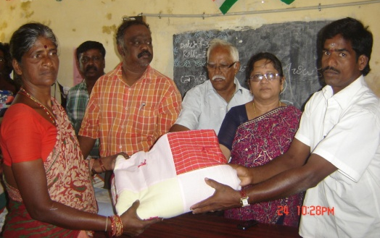

Quilts were distributed to about 250 families this year.

The roof of the Community Hall at Irrukam was blown away by the cyclone (Lila). About 35 asbestos sheets were smashed into pieces. We are thankful to CASA for their timely help to repair and replace the asbestos sheets.

