Second batch started with 29th September. 36 Youth were underwent this training programme.

We have organized the 10 days computer training program at CSI Christ church Kodungaiyur. We have also trained the Students in the following:
- How to write the CD.
- Excel formulas.
- Shortcut keys in MS-Office.
- How to insert the Picture and ClipArt’s in the Word.
- Presentation of Project in the PowerPoint.
- Usage of the PageMaker & CorelDraw and Cleared their doubts in the Ms-Office.

During the period under report 186 students underwent this training Programme.

Long term Computer Courses:

(1)Software course:

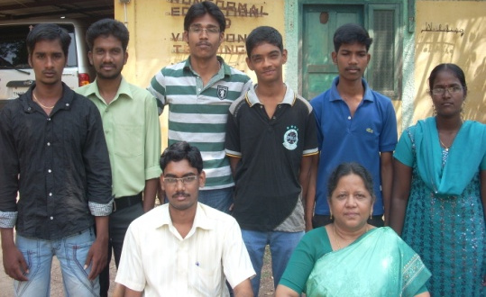
30th batches of students have completed their studies and now the 31st batch is undergoing the training (Govt. batch 27th completed and 28th batch undergoing institute certificate course)

(a) Job Oriented Desk Top Publishing:
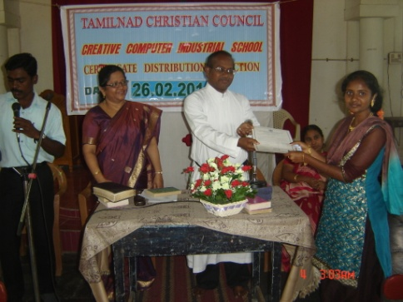
Computer Fundamentals, MS-DOS, MS-Windows’98/XP, MS-Office
XP, PageMaker, Corel Draw, Photoshop, Scanning Fundamentals of
Internet, Email and browsing, Lamination and Spiral Binding.

Duration: 6 months.
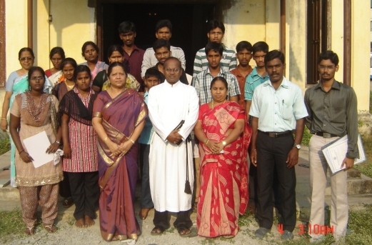
During the period 18 students underwent this training and most of them were placed in good Jobs.

(b) Computer Aided Accounting Management:

MS-Windows’98/XP, MS-OfficeXP, Scanning Fundamentals of Internet,
Email and browsing, Basic Accountancy and Tally.
Duration: 6 months.

(c) Data Entry Operator:
Duration: 3 months course.

While evaluating, more than 95% of the students are placed in good jobs earning income ranging from Rs.3500/- to Rs.9500/-.

- Tailoring Programme :

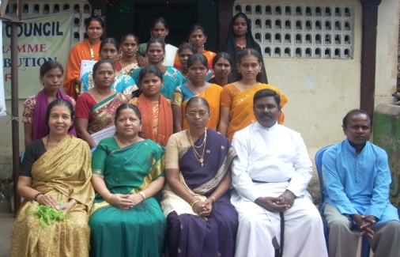
Two batches of students underwent tailoring training at our Thirukoilur branch office. About 31 Students learnt tailoring during this period.

- Typewriting Programme:
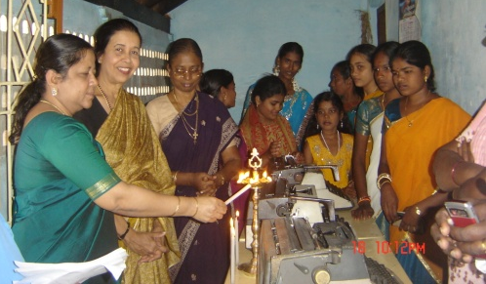

Inauguration of Typewriting Programme was held on 11th Feb., 2011 at Thirukoilur. Introduction of the programme as given by Dr. Ms. V. Esther Kathiroli, Director, TNCC. Inauguration of Typewriting Programme was done by Rev. Samuel, Aaron Church, Tiruvannamalai. Certificates were distributed to the Tailoring Students on that day.

5) Global Warming and Climate Change programme:

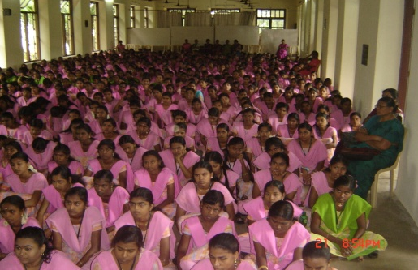
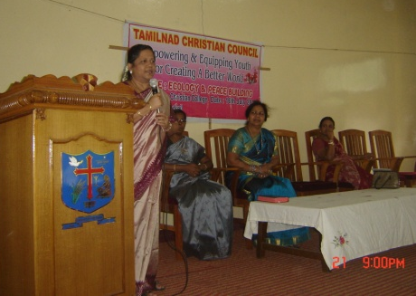
The occurrences of natural calamities have now become an annual feature in some and monthly event in other parts of the world. This year the unusual massive earthquake with a very high magnitude of Tsunami hit Japan. It also reminded us of the Tsunami that affected us in the year 2004. Thousands of people in Japan lost their loved ones, their homes and house hold things. Australia, Pakisthan and many countries experienced unusual hurricane, rain and flood. China experienced both severe drought and flood. Report says as of July 2011, different places of USA experienced 1167 confirmed Tornados. According to recent survey done by US, about 3146 scientists agreed that the human induced global warming and climate change is real.

Therefore we as church had felt the respon -sibility to enlighten people about the

