- Peace Building and Conflict Management- Training of Trainers Programme:
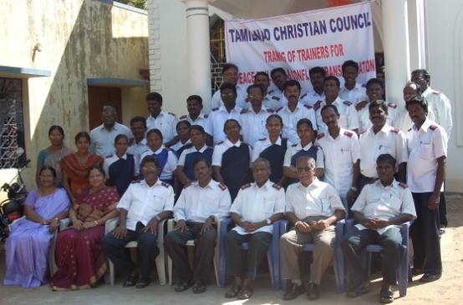
i)At Tirunelveli: Peace Building and Conflict Management Programme was held at Tirunelveli from 20th to 22nd January 2011 at Salvation Army Church, Tirunelveli. The topics covered under the training programme are: Introduction and Approaches to Peace Building; skills on peace building such as- Creative Response; Empathy; Co-operative Power; Managing Emotions; Mapping Conflict; Negotiations; Meditation; Broadening of Perspectives.
35 Persons participated in the training.

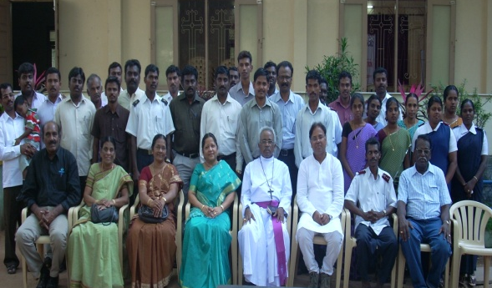
ii) At Thoothukudi: Peace Building training programme was conducted at Good News Centre, Thoothukudi on 24th and 25th of January 2011. Youth from the CSI Thoothukudi Diocese and students from the Catholic Church Seminary participated in the training.
About 55 persons underwent the training.

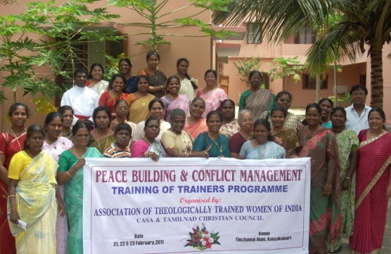
iii) At Kanyakumari: The Training of Trainers in Peace Building and Conflict Management was held at Thozhamai Illam, Kanyakumari from 21st to 23rd of February 2010. This programme was mainly conducted for the Theologically Trained Women of India, Tamilnadu Region.
About 32 Women from different denominations attended the training programme

- Computer Education Programme for Rural Dalit Children: Short term Courses

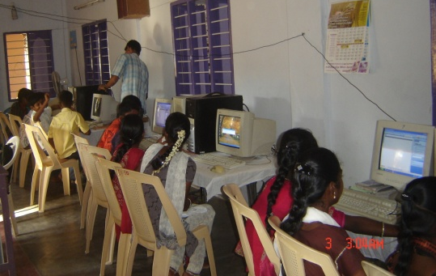
The Chief aim of this programme is to empower dalit children in the villages through computer education. The present education and economic set up is ‘to know computer is to know life and find life’. Computer education helps young people to self motivate themselves, find a meaningful career, to climb upward in economic pursuit and regain their dignity ultimately. Therefore about 10 to 12 computers were transported to every location and placed for the students to operate the computers. Theory was taught through LCD Projector and every student received opportunity for practical exposure to computer for about 5 to 6 hours a day. On the final day tests were conducted on theory and practical. Certificates were issued with the credits marked.

a) Kadambattur, Tiruvallur Dt.

The programme was conducted on 27, 28 and 29th April 2010 at C.S.I Resurrection of Christ Church Kadambattur. The training program began at 27th morning 10:00 a.m. Every day we start the programme with prayer and devotion. 24 Youth underwent this training and completed it successfully.

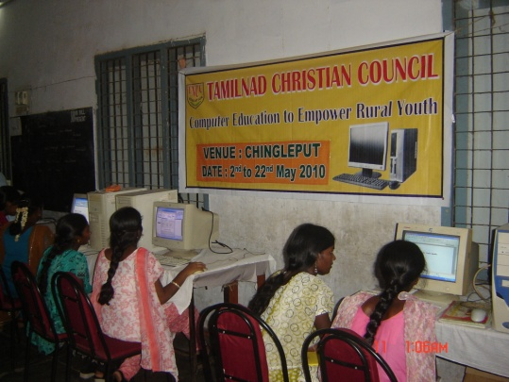
b) Columbus Higher Secondary School, Chingleput: This programme was conducted along with CSI Madras and Community Service Center from 2nd May to 12th May 2010. 103 Youth from surrounding villages registered for the training and 97 Youth completed the training.
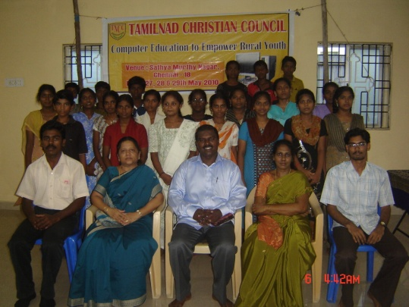
c) Sathya Mur -thy Nagar: The training program began from 27th and 29th May 2010. 29 Youth were Registration in this training. But 27 Youth were underwent this training programme.

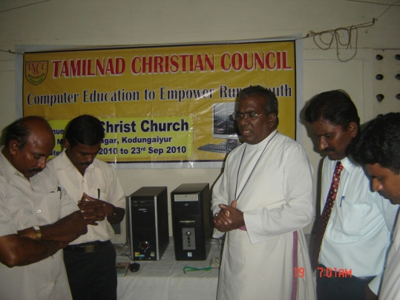
d) CSI Church, Kodungaiyur This training programme was conducted from 12th to 23rd Sept 2010 & 29th Sept to 11th Oct 2010.

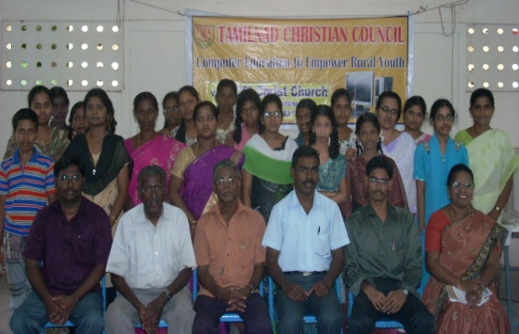
Rt. Rev, Dr. V. Devasahayam, President - TNCC, Inaugurated the computer programmme. Tamilnad Christian Council organized the 10 days computer training programme at CSI Christ Church Kodungaiyur. Every day we start the programme with prayer and devotion. Batch –1 26 Youth were underwent this training programme.

