Tamilnadu Social Welfare Board we are implementing Rajive Gandhi National Creche Scheme at the following places. Approximately 20 to 30 children between age group from 2 to 5 years receive care and attention.
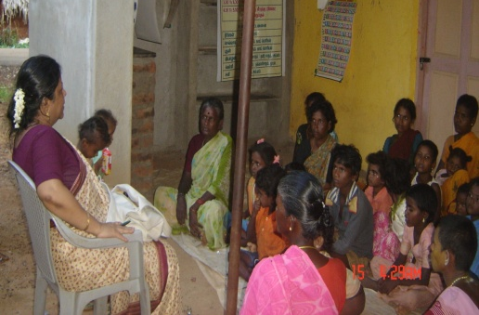
1. Kazhanipakkam, Ambur
2. Nemalur, Gummidipoondi
3. Pondavakkam, ,,
4. Memorial Hall,
5. Kilpauk
6. Delta, Kadalur
7. Parameswarimangalam
8. St. Paul’s Church, Vilupuram,
9. Kollathur, Chennai.
10. Thandalachery, Gumidipoondi.

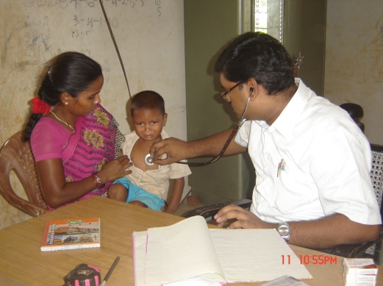
The Director regularly visit all the Creche Centres and also meets the parents of the children. Medical check-ups were done to all the children in all the crèches. In most of the places even the village people were given medical treatment. Emergency medicines were kept in the centres.

- Bethesda Home:

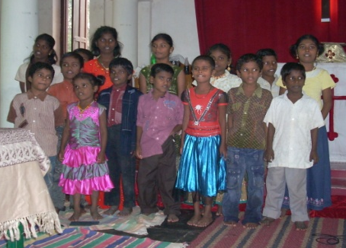
Bethesda Children home is our orphanage at Chingleput. In our Bethesda Home 16 children are staying and they are studying in the nearby Government School. The maintenance of the home and care for the Children and other expenses of the home and part of the functioning of Chingleput Rural Service and Development Center are met through the income we receive as rent from the shops.

Children Home at VOC Nagar, Chingleput was established specifically to provide care for the HIV positive children and the mentally challenged children. The Karunai Jeevan Trust helps us to run this project and also take care of the maintenance.

10.Adult Literacy Programme:

We were conducting Adult literacy Programme for the past 10 years in 20 different centres. The project was closed. Yet upon the request of the local people we are continuing the programme at four centres viz.

Kancheepuram -Vedal (Guduppu Community );
K.K. Nagar at Thirukazhukundram,
Kulipanthandalam
Oragadam

11.HIV/AIDS Awareness Training Programme:

During this year HIV/AIDS Awareness Programmes have been conducted at 10 places.

HIV/AIDS Awareness Training Programmes :-

S.No. | Places | Participants Details | No. of  Participants
1. | Chennai | Youth group | 30
2. | Chennai | Youth group | 28
3. | Ambur | Women group | 35
4. | Chingleput | ,, ,, | 42
5. | Madurai | Youth group | 58
6. | Irukkam Island | Youth | 25
8 | Tirunelveli | Youth | 35
9. | Gumidipoondi | Women group | 52
10. | Kancheepuram | Women | 32

World AIDS Day : We have organized a Rally and an awareness programme along with the CSI St.Thomas Matriculation School Children, St. Thomas Mount. Mrs. Rokkiah (a) Salma, Chairman, Tamilnadu Social Welfare Board was invited as the Chief guest.
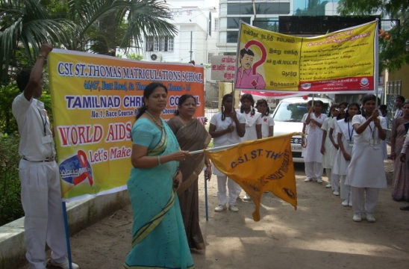
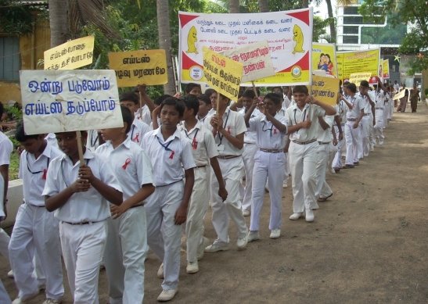

12. Ambur Resource Center - Dedication:

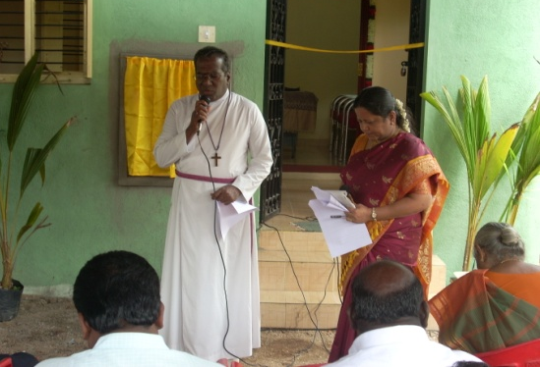
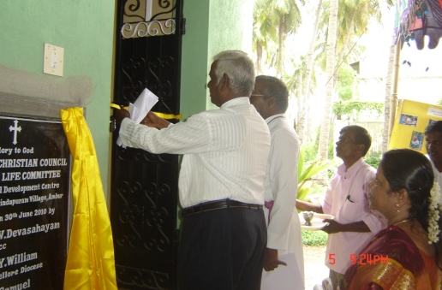
The newly constructed Ambur Resource Center was dedicated by our President Bishop, the Rt. Rev. Dr. V. Devasa -hayam, on 30th June 2010. The Rev. Dr. J. Samuel, President of the I.E.L.C. opened the building by cutting the ribbon. Mr. Sunder Kumar, our treasurer and some of our Members, Staff and the beneficiaries attended the programme. Dr. Ms. V. Esther Kathiroli, Director welcomed and honored all the dignitaries. Dr. Jayakaran Isaac, our member, Dr. Joel Nesakumar, Medical Director, Bedestha Hospital, Rev. John Baskaran, Vice President, CSI Vellore Diocese offered greetings. Our President delivered Lord’s Message.

13. Community Development Programme at Irrukam:

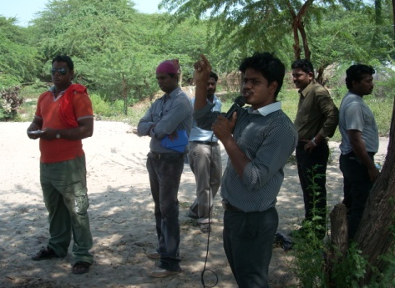
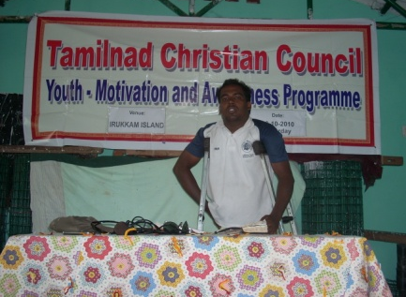
Last year we have planted cashew nuts seedlings and casurina seedlings. Some of the cashew nuts trees dried due to over heat but some have survived and have grown big. But all the casurina seedlings have survived and have grown.

Women programme and children programme are continuing. Youth awareness and motivation programme was conducted by the youth at Chennai to the youth at Irrukam.
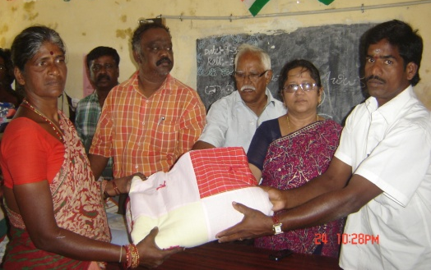

Quilts were distributed to about 250 families this year.

The roof of the Community Hall at Irrukam was blown away by the cyclone (Lila). About 35 asbestos sheets were smashed into pieces. We are thankful to CASA for their timely help to repair and replace the asbestos sheets.

14. Visit of Rev.Dr. Michael Kinnamon, General Secretary, NCCC-USA.

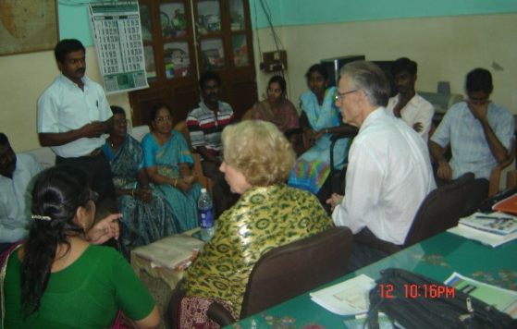
The Rev. Dr. Michael Kinnamon, General Secretary, National Council of the Churches of Christ in the U.S.A. and his wife visited our office and had a meeting with the Staff. He appreciated the various activities carried out by our Council. He also shared his experiences during his stay in India as well as NCCC-USA.

15. Director’s overseas visit:

I visited two countries viz. the Netherlands and USA during this year to meet the funding agencies to introduce the activities of the organization and to raise funds. In the Netherlands, I visited the organizations viz. the ICCO-Ker-in-Actie, World Servants, Simavi and in USA I visited the NCCC-USA, Presbyterian Church, Church World Services and many individuals and churches.

16. Programmes with other Organisations/Institutions

Attended World Christian Tamil Convention at Bishop Heber College, Trichy
On 21-05-2010

Attended NCCI Meeting at Bangalore on 16-09-2010.

Attended Lay Leaders meeting at Inter-Church Service Association (ICSA) office, 24-09-2010 & 25-09-2010.
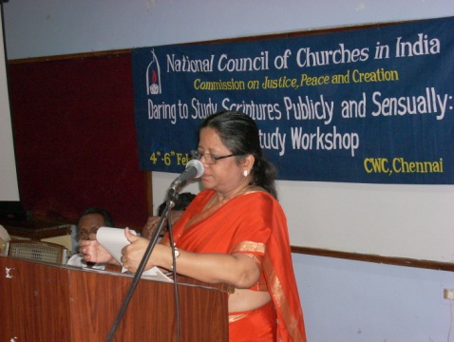
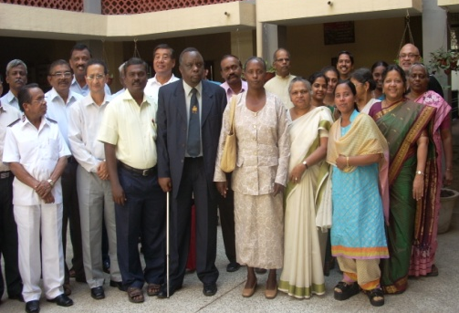
The National Council of Churches in India organized two workshops at the Church Women Centre, Gurukul campus from 4th to 6th February 2011 on the theme “Daring to study Scriptures Publicly and Sensually- A Bible Study Workshop” & “Theological Roundtable on Disability” from 8th to 10th February 2011. I am thankful to NCCI for inviting me to chair the workshops and to deliver chairman address.

Mr. V. Samuel, Youth Secretary, on behalf of TNCC attended the NCCI Youth meeting at Cochin on 08-09-2010.

Mr. V. Samuel & Mr. Thangaraj attend the meeting of Community Service Center at Bangalore on 25-10-2010.

17. Future Plans:

- Peace building programs

The center considers organizing peace building programs all over Tamilnadu is the need of the hour. This program ought to take up a grand fast manner to encourage people to become peace lovers and peace builders. It should be done in massive scale.

- Maathamma project

The practice of dedicating girl children to the temple deity Maathamman is still in practice in the Tamilnadu-Andhra borders. This must be stopped at all cost. The center has drawn out plans to go ahead with the issue and empower women in the area.

- Ecological concerns-Global warming

The issue is becoming serious day by day as just few pockets are committed to this task of reshaping the earth’s conditions

- Women’s center

This is one of major requirements for the enter to grow as well as to effectives carryout it‘s essential mission and ministry to the women who are stuck in midway.

- Building Project

- The building project remains only as dream now. It is yet make a good beginning and get good going. We wish all things will fall in its place at the earliest by the grace of God and by the support of the bishop. We only wish the construction will begin with blessing of our bishop and come to completion and be dedicated by the hands of our bishop.

- “Community Center” at Chingleput is our priority for the moment. We hope this center will serve us as an excellent resource and space for mission work. We shall submit the proposal at this august counsel for direction, approval and support.

18. Conclusion:

We humbly submit ourselves to the will of God as we conclude this report. There are miles before us. There are great many issues pending to be addressed and resolved. Our vision is widening day by day as we are moving in to more difficult times. We are also facing severe financial crisis as raising funds have become very difficult. We request your prayers, support in the days to come.

I conclude with deep sense of gratitude to our President-the Rt. Rev. Dr. V. Devasahayam, Vice-President- Rt. Rev. R.D. Vijayakumar, Mr. B. Sunder Kumar, the Treasurer; Rev. S.R. Paul Aruldoss, the Convener; and all the Members of the Executive Committee and Economic Life Committee for their encouragement, sustained support extended to me and my staff all through these days and for their valuable suggestions and guidance at the time of importance.

On behalf of the Officers and Members of the Executive and Economic Life Committee, I express my sincere gratitude to all the donor agencies and few individuals for their generous contributions.

We place our trust in God who has called us and anointed as witnesses of His marvelous light. To God alone be the glory.

Dr. Ms. V. Esther Kathiroli,
Secretary & Director.

